Dashboard Improvements – Version 3.0

# List of Dashboard Improvements – Version 3.0

* Addition of new SM monitors for Counter table – Schedule and Non-Schedule Records.
* Addition of new SM RWS monitors for RWS Request Reply GET and POST Web Services.
* Application Name renamed from SM7 to SM9 to reflect correct SM version.
* New Screens for Maintenance of Monitors and Monitor Descriptions and simplified Monitor Management. Available to Dashboard support team and admins only.
* Historical Reporting enhancements to enable sorting, freeze header row when scrolling and other formatting changes.
* Improve Performance of Reporting by archiving and deleting old non backlog data.

# Addition of new SM Counter Monitoring.

## Changes

2 new monitors added to Dashboard to support monitoring of the counter files.

### Counter Value for Schedule record

* This monitors the schedule record for Current value. This will be tracked in the P1 area of the Dashboard.

### Counter Value for records other than Schedule record.

* A second monitor is in place to monitor all other counter files for breach of that value. This will exist in the P2 area of the Dashboard.

The Monitors are set up as:  Current Value > 1,800,000,000 **Yellow**, Current Value > 2,000,000,000 **Red.**  Otherwise, response is ‘OK’

## Benefits

* This is to ensure that we do not exceed the max numbering value of the tool with any of our records which use the counters application.
* Maximum system generated numeric value in the tool : 2,147,483,647

Screen showing Dashboard Detail page with these new Counter monitors

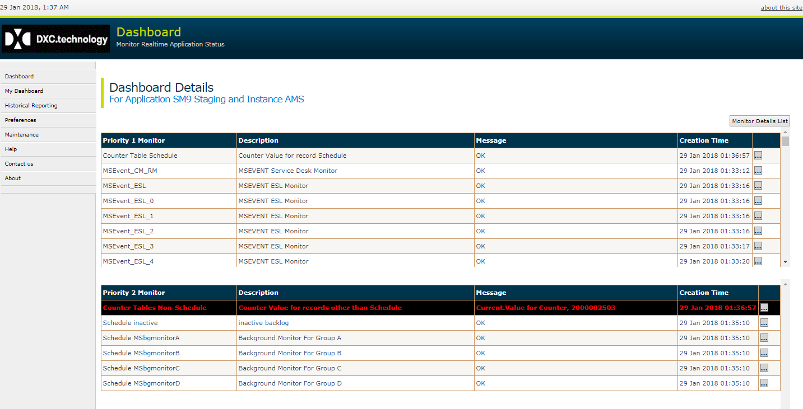

Screen showing Backlog Alerts on Main Dashboard page with these new Counter monitors.

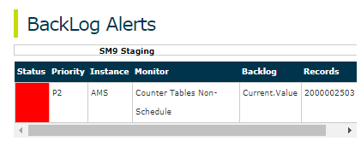

# Addition of new SM RWS monitors for RWS Request Reply web services.

## Changes

### List of new RWS monitors

New monitors for RWS Request Reply GET and POST Web Services added to the dashboard. These are as below.

* RWS GET Test Service Status
* RWS GET Application Status
* RWS GET Cache Status
* RWS POST Ref AssignmentGroup
* RWS POST RefContact

These monitors will be shown under the application ‘SM RWS’.

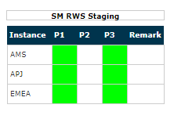

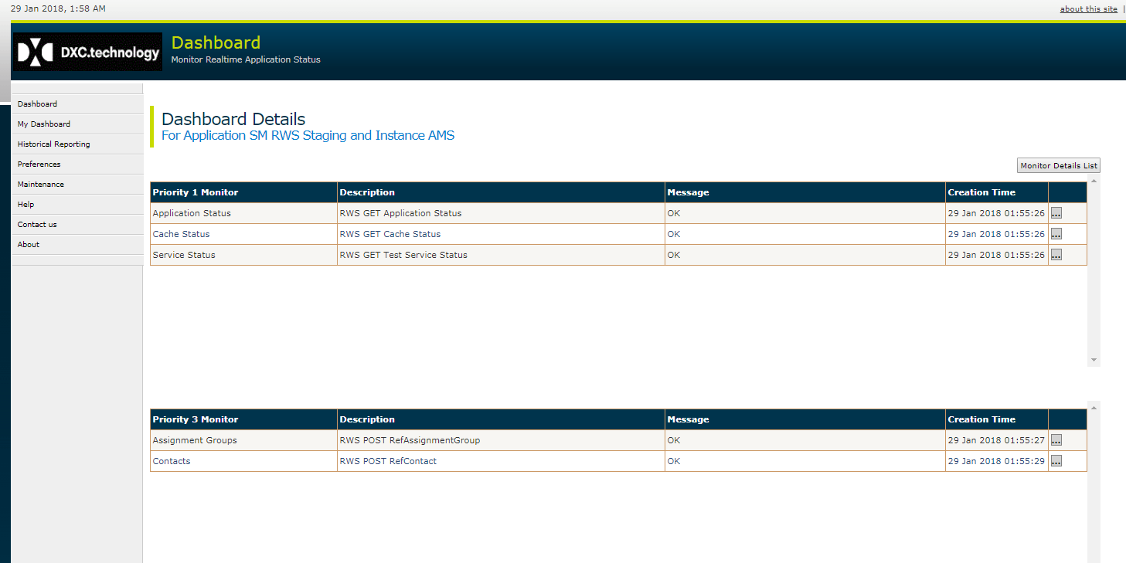

**Below Monitors for RWS GET services will have priority P1.**

#### RWS GET Test Service Status –

* Checks if the GET ‘Test’ service is working.
* Checks response of the service from both servers for a region and displays on Dashboard Detail Page
  + If message from both servers matches ‘Workflow RWS OK’, then status is OK.
  + If not ‘Error’ is reported with response message. **Red**

#### RWS GET Application Status

* Checks if the GET ‘Status’ of the application is up.
* Checks response of the service from both servers for a region and displays on Dashboard Detail Page
  + If message from both servers matches ‘Green, then status is OK.
  + If not ‘Error’ is reported with response message in **Red**.

#### RWS GET Cache Status –

* Checks response of the ‘CacheStatus’ GET service from both servers for a region and displays on Dashboard Detail Page
  + If response code is 0 from both servers and there is no mismatch in cache counts and counts are not 0 then status is ‘OK’.
  + If there is a mismatch in the counts of both server caches more than threshold (default=10), then the last update time of both server caches are checked. If it is older than last 2 cache intervals, then error is reported. Also, the response code, response message and record count from the response Message Header are shown with message ‘Error’ in **Red**.

**Below Monitors for RWS GET services will have priority P3.**

#### RWS POST RefAssignmentGroup

* Checks the response from POST RefAssignmentGroup Web Service from both servers and displays on Dashboard Detail Page
  + If response code is 0 from both servers then status is ‘OK’.
  + If the response code is not 0 for any of the servers, then the response code, response message and record count from the response Message Header are shown with message ‘Error’ in **Red**.

#### RWS POST RefContact'

* Checks the response from POST RefContact Web Service from both servers and displays on Dashboard Detail Page.
  + If response code is 0 from both servers then status is ‘OK’.
  + If the response code is not 0 for any of the servers, then the response code, response message and record count from the response Message Header are shown on the Dashboard Details screen with message ‘Error’ in **Red**.

### Other features

* When an error is reported from any of the above RWS Web Services, the URL and JSON response will be available from each server and shown in the Monitor Details ‘Error Detail’ section. This can be accessed from the ‘…’ button next to the monitor on the Dashboard Details page.
* Also, details can be checked for past monitors in historical reporting.
* OM Monitoring for RWS P1 monitors will also be available.

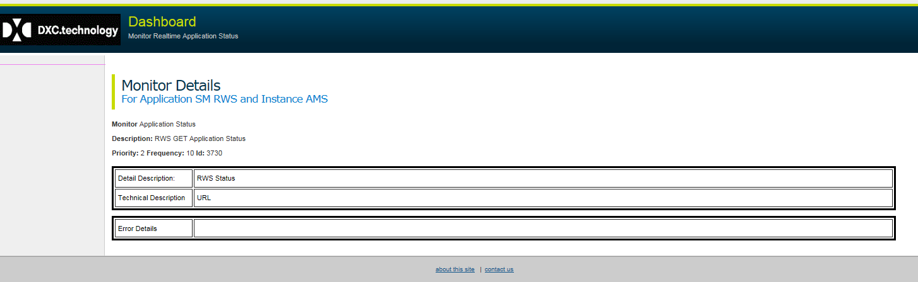

## Benefits

* Monitoring and faster detection and resolution of RWS issues.
* In case of error, JSON response will be shown. This will save time in troubleshooting.

# Application Rename from SM7 to SM9

## Changes

Application name on Main Dashboard page will be renamed from SM7 to SM9.

Reporting will also show SM9 instead of SM7

## Benefits

Application name will reflect current SM version.

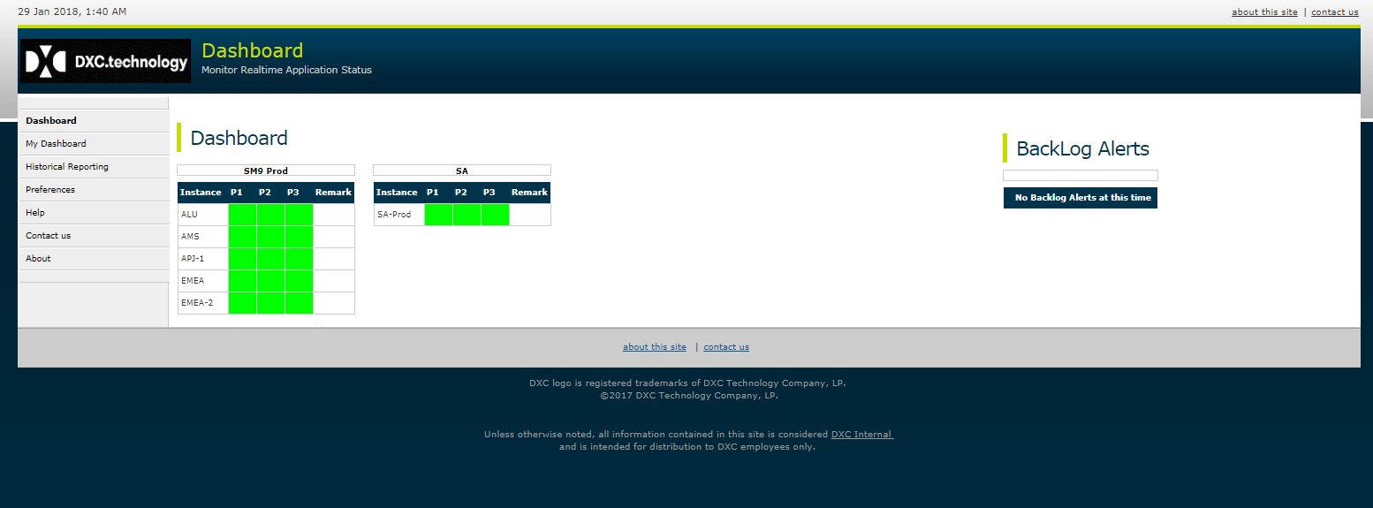

# Monitor Management

## Changes

### Manage Monitor Information

* New Screens for Add/delete or update of Monitor information like Monitor name, application, instance, priority and description. Previously, this information could only be added through configuration files.
* Monitors can now only be added or updated though this web interface.
* New monitors will not be able to be added via configuration files. They are only used in configuration files to link the query to the monitors.
* For monitors to function properly, application, name and instance in database should exactly match the application, instance and name in configuration file.

### Manage Monitor Descriptions

* New Screens for Add/delete or update of Monitor detail and technical descriptions. Previously, this information could only be entered through SQL scripts.

### Security

* Changes to monitor names, application or instance will affect monitoring. Hence these screens are accessible to Dashboard support team and admins only.

Monitor Add/Edit/Delete Screen

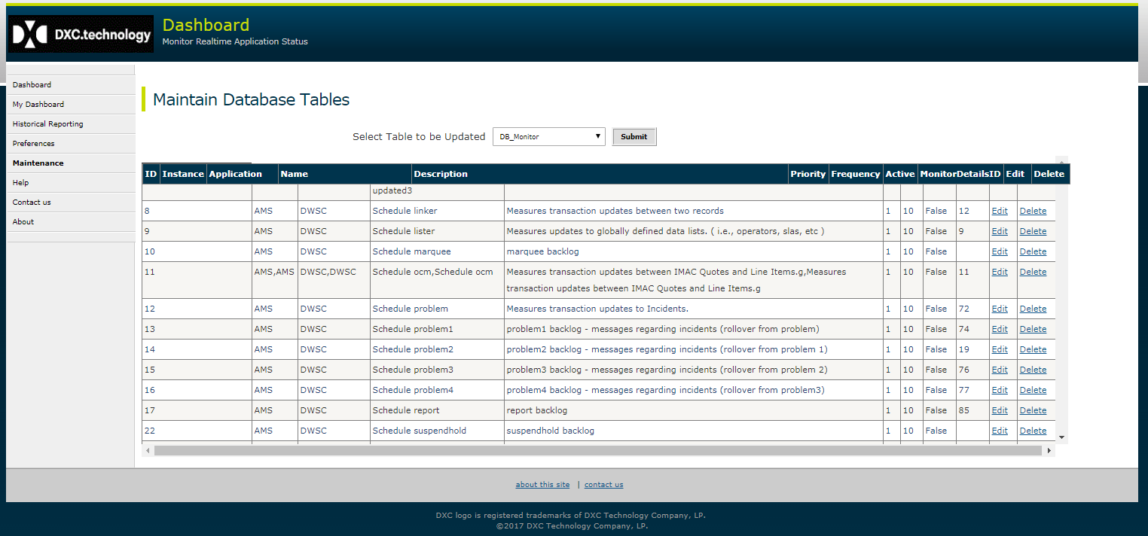

Monitor Detail Descriptions Add/Edit/Delete Screen.

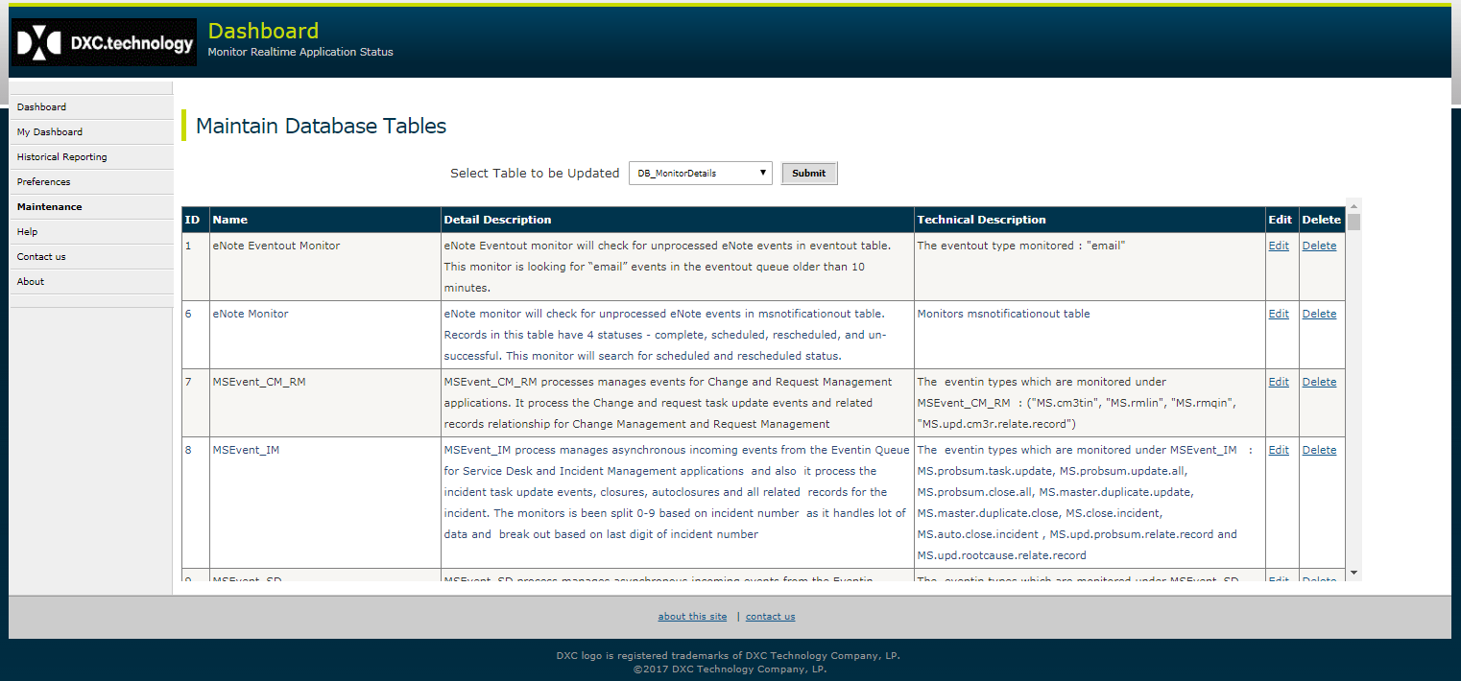

## Benefits

* Monitor information Management will be simplified though web interface. Maintaining through configuration files and SQL scripts was very error prone and created many duplicate and incorrect monitors.

# Reporting Enhancements

## Changes

Below improvements have been done for Historical Reporting.

* + Allow Sorting of Report Columns by clicking on the header column.
  + Fix Column Headers at the top when scrolling report data in grid.
  + Improved formatting of Backlog Crosstab report by shrinking the message for backlog duration, from and to time.

## Benefits

Will allow better analysis of report data.

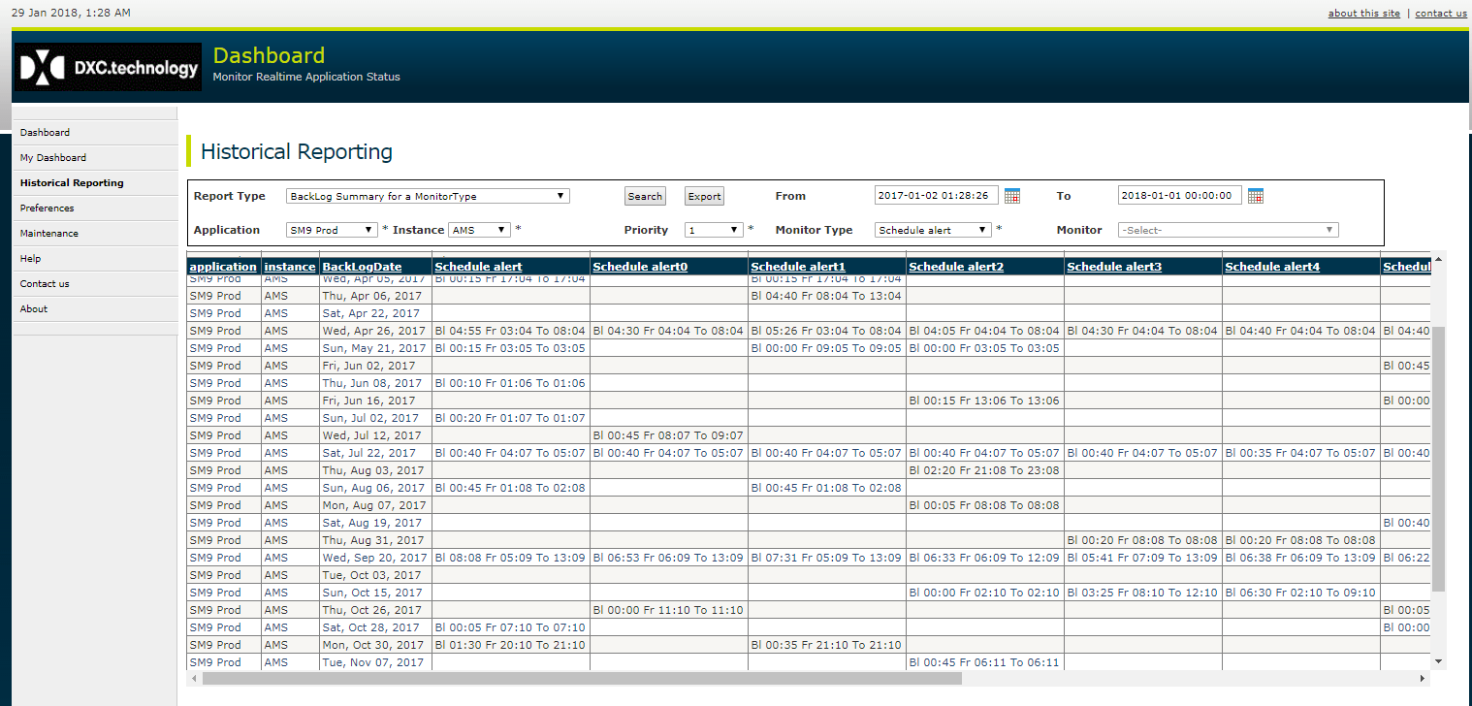

# Performance Improvements for Reporting

## Changes

Past Non backlog data older than a month will be archived and deleted, as it does not have any use.

This will not affect current monitoring or content of Historical Reporting.

## Benefit

This will improve the performance of report queries, as backlog table size will be reduced. Currently, the size of the Backlog table is very large (about 400 million records).